Materials Science and Technology
University of Crete
Project in Surface Science and Nanomaterials
Author’s Name: Margas Michail (413)
Subject: Scanning Tunneling Microscope (STM)
Supervisor Professor: Ioannis Remediakis (Assistant Professor)

Contents of my presentation
- History
- How the microscope works
- Uses of this method
- Tunneling current
- An example with numbers
- Photo gallery
- Bibliography

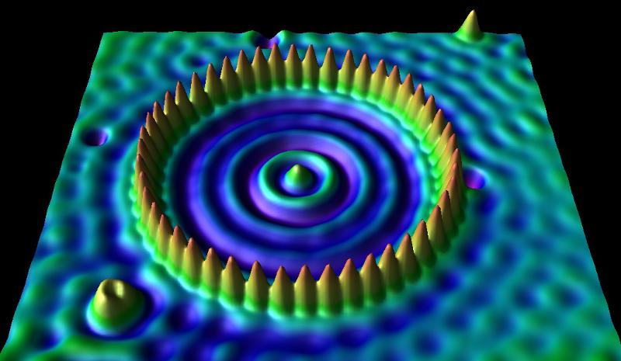
Image source: Iron atoms on the surface of Cu (111) http://physics.stackexchange.com/questions/63043/dark-and-bright-areas-around-atoms-in-a-scanning-tunnelling-microscope-image

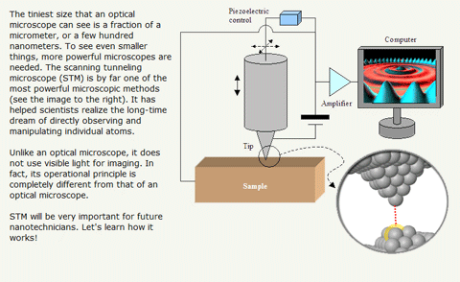
Image source: http://concord.org/stem-resources/scanning-tunneling-microscopy

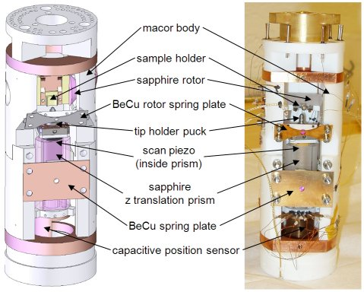
Image source: Diagram and photo of microscope http://hoffman.physics.harvard.edu/research/SPSTMresearch.php

May-June 2014

